Tutorial for using VS code on OSU’s HPC cluster:
- Request HPC access

https://it.engineering.oregonstate.edu/hpc

- Enable your HPC account in TEACH

https://teach.engr.oregonstate.edu/teach.php?type=want_auth

- Connect to the COE HPC Cluster

ssh username@submit.hpc.engr.oregonstate.edu
Note. Make sure to change the ‘username’ in the command to your own username, and it should be the prefix of your school email.

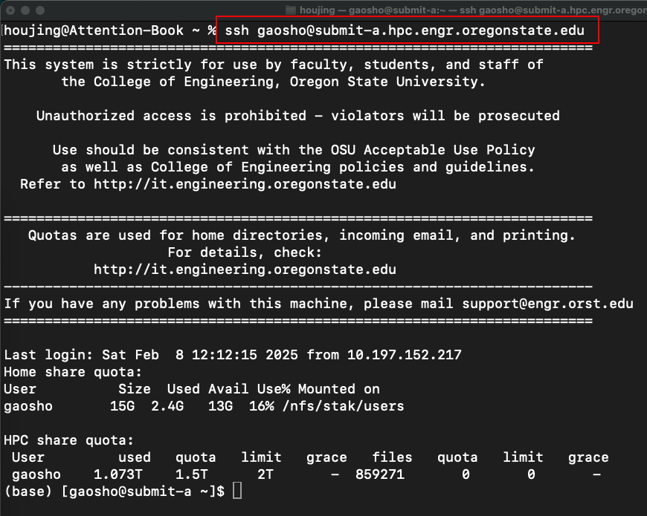

If you use a Windows computer, download MobaXterm first and launch the SSH client through MobaXterm.

- Install Mobaxterm

https://mobaxterm.mobatek.net/download-home-edition.html
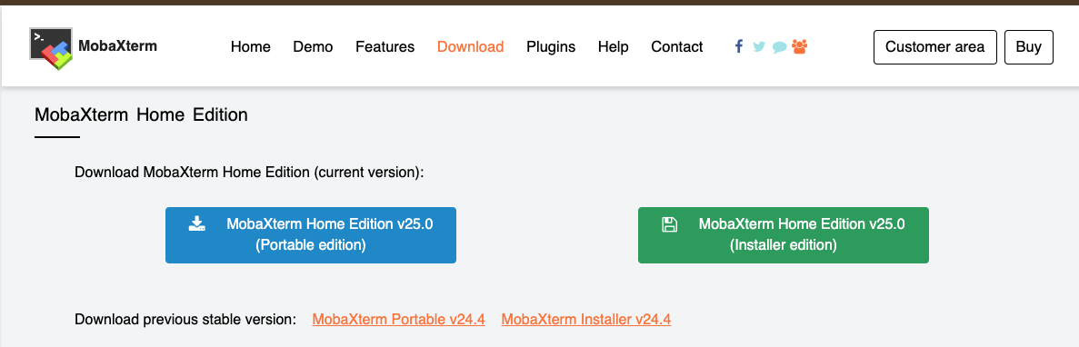
The portable edition is more easy to install.

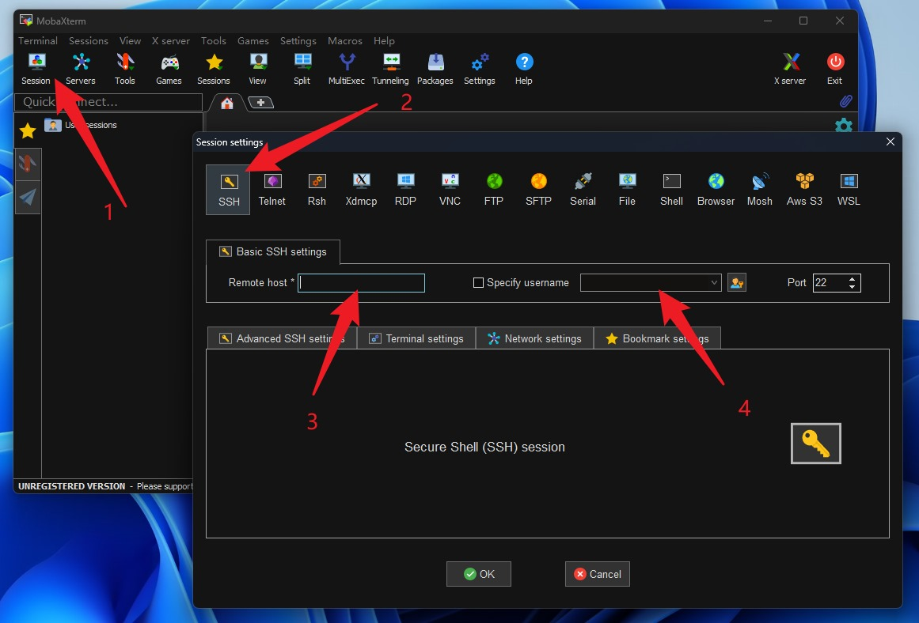

ssh username@submit.hpc.engr.oregonstate.edu
Username: username
Remote host: submit.hpc.engr.oregonstate.edu

- Apply extra storage
Note: Everyone has a fixed 15 GB quota. Exceeding the quota can cause jobs on the cluster to fail, and other things to not work properly.
Researchers are given access to a global HPC scratch directory with a 1 TB quota that they can use to run their jobs from and to store data to. The global scratch directory is located in /nfs/hpc/share/username, where your userame is your ONID, or OSU Network ID.

Run in terminal:

ln -s /nfs/hpc/share/username hpc-share
Note: put everything there: cd hpc-share

- Install VS Code and extensions
VS Code issues (from OSU’s IT office): I have received a number of complaints over the last few weeks that users are having trouble logging in using VS Code. One user reported that the latest working version for them was 1.99.3, but many have experienced issues with VSCode versions > 1.99.3. I have had one user report success with VSCode versions > 1.102.0 but upgrading has not resolved issues for others. If you are having trouble logging in using VS Code, my advice is, apply the latest updates and try again, and if that does not work, revert back to 1.99.3 – right now that seems to be the last stable version for logging in. I would be interested in hearing from others if VS Code 1.102.x is working well for them.

- Download and install from https://code.visualstudio.com/
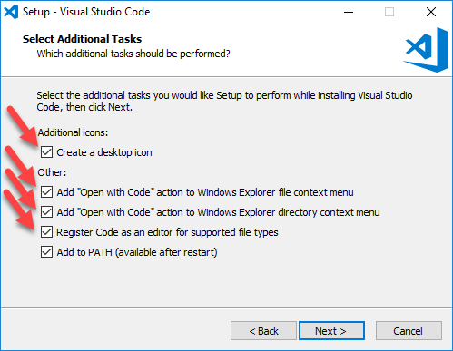

- Install extensions
  - Python
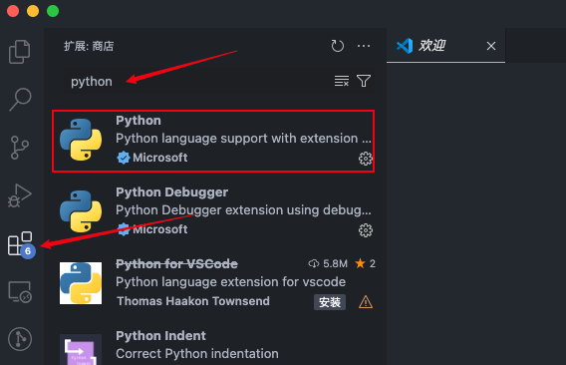
  - Remote SSH
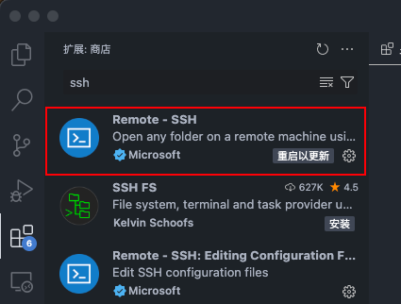

- Connect cluster through VS Code
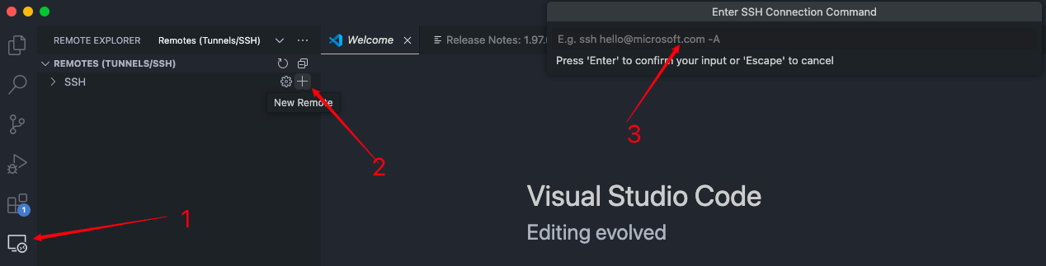
ssh username@submit.hpc.engr.oregonstate.edu
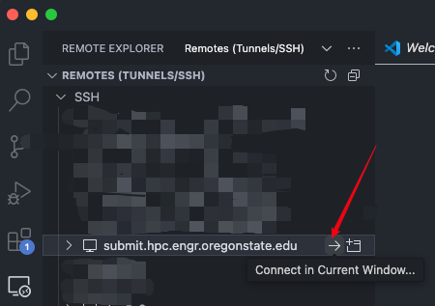
Check if you connected to the cluster
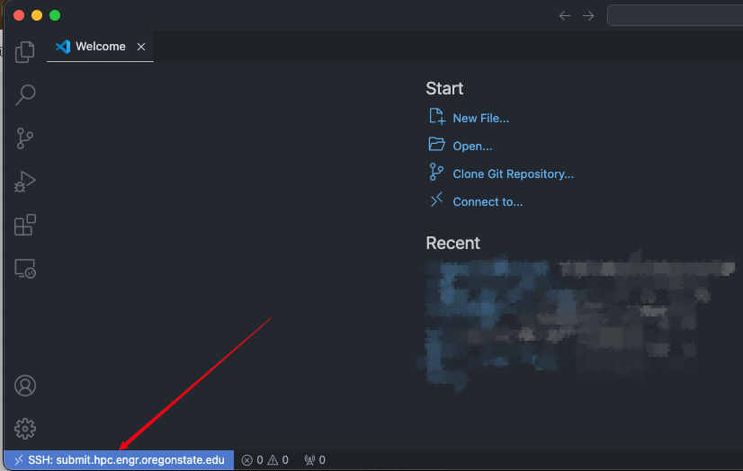
To open the terminal in VS Code: ctrl + J
Check the memory usage: du -ah --max-depth=1 | sort -hr
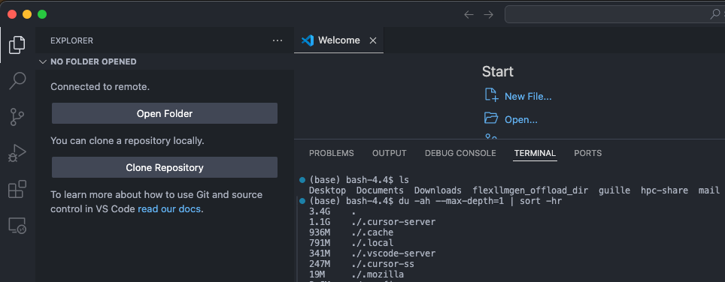

- Run demo on cluster:
Clone demo code from github

Run in terminal:
git clone https://github.com/shwgao/CS-ECE-599-labs.git

Open
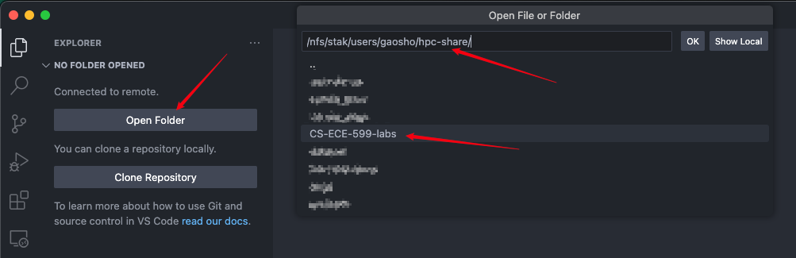

Run the demo code:
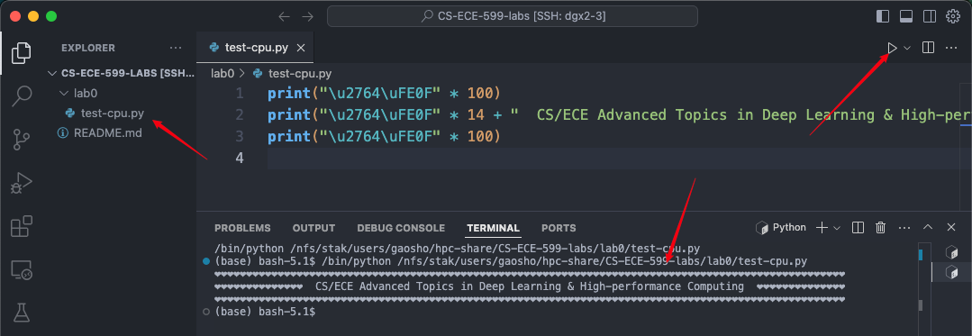
Note: you may install the Python extension again.

- Request compute resources

Request one gpu on node gpu/dgx2 for one hour with RAM 64 GB

Run in command
- srun -A eecs --time=0-01:00:00 -p gpu,dgx2 --gres=gpu:1 --mem=64G --pty bash
- nvidia-smi
- hostname -f
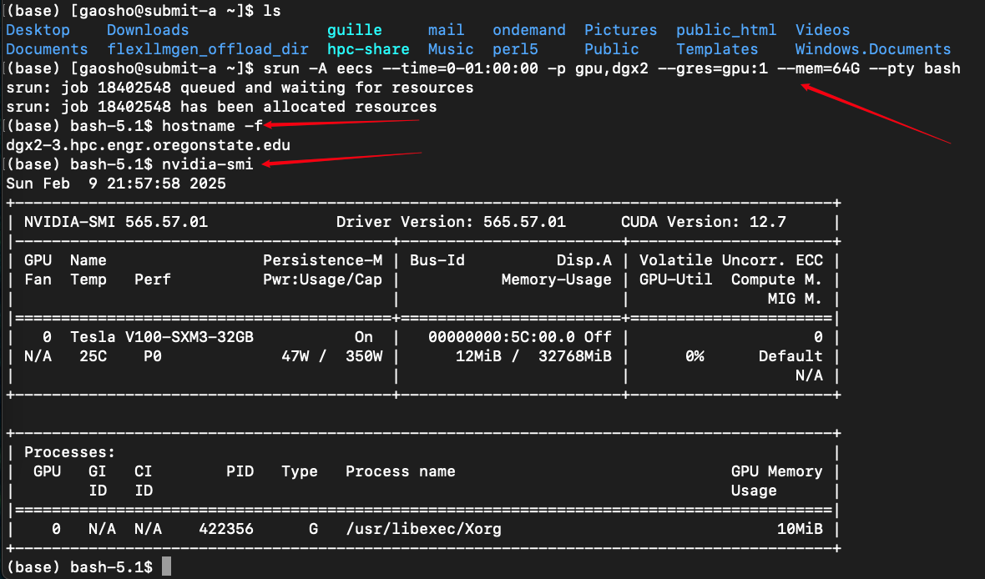
- Access the GPU resource through VS Code

ssh username@{output of the command hostname -f}
